

A Project Report

On

**SMART COMMUNICATION**

Batch Details

|  |  |  |
| --- | --- | --- |
| Sl. No. | Roll Number | Student Name |
| 1 | 20211CSE0082 | ANANDHU PRADEEP |
| 2 | 20211CSE0062 | N SAI DINESH |
| 3 | 20211CSE0180 | GALIVEETI THARUN REDDY |

**School of Computer Science,**

**Presidency University, Bengaluru.**

Under the guidance of,

**Dr. SUKRUTHGOWDA M A**

School of Computer Science,

Presidency University, Bengaluru

**CONTENTS**

1. Abstract
2. Introduction about Project
3. Literature Review
4. Objectives

## Methodology

## Architecture Diagram

## Modules

1. Timeline for Execution of Project
2. Expected Outcomes
3. Conclusion
4. References

**1.ABSTRACT**

India’s handicrafts sector is indeed rich and forms an integral part of the economy and culture of the country. Millions of people are engaged in it, providing opportunities especially in the peripheral regions where the art and skills are a family heirloom. Even with such important percentage, legal handicrafts are still absent in a considerable percentage of the global economy. This is mainly due to adverse effects such as low levels of digital literacy, use of intermediaries, and unavailability of effective markets.

The E-COMMERCE FOR ARTISANS’ platform is an information and communication technology-based solution that is intended to change the way artisans interact with the market both at the local and international levels. The platform allows artisans to present their work without any agents and to make the maximum profit possible. The platform provides specific and customizable features for rural artisans which include easy product uploads, secure payments, event organizing and promoter, and advanced payment systems such as COD to build trust.

This project provides a certain digital intervention in order to assist the craft and artisans’ community in enhancing its productivity, pursuing new markets and promoting its self-management. The project is also significant culturally as it seeks to protect the traditional arts and crafts of India from dying out in the present economy. The platform is simple to navigate and is available in several languages which means even an artisan with very basic computer skills will be able to use the platform. This helps in reducing the technological disparity thereby addressing economic growth for all.

**2.INTRODUCTION**

In India, the rural craftsmen often face challenges in accessing the right avenues to sell their products across the borders. This initiative intends to create an e-commerce site for the rural artisans who wish to sell their hand-made creations on a larger scale overcoming the traditional limitations. The platform is designed in a simple manner that helps the artisans in listing the products, handling the sales, and availing the services of other artisans while organizing for events, all these without the need of complicated technical skills. Also, the platform allows performing transactions around the world albeit at the start, it supports merely Cash on Delivery (COD) which in turn shall be extended to full online payment system after every other verification is completed in order to build trust between the buyers and the seller.

**3.LITERATURE REVIEW**

* The present state of the available platforms which artisans can use to display and sell their works presents both challenges and opportunities. In order to come up with a comprehensive model of e-commerce meant for artisans, there is need to study the existing designed solutions and their advantages and disadvantages. This subsection explains and contrasts many such concepts, from conventional assortments to contemporary virtual notions, and evaluates how useful or inadequate they are in assisting craftsmen in the craft industry.
* **Traditional Handicraft Marketplaces (Physical Stores and Exhibitions):**  
  These provide artisans with direct, face-to-face interactions with customers, allowing buyers to physically inspect the products. However, the high operational costs, including rent and staffing, limit the profitability for artisans. Moreover, artisans in remote regions are often excluded from such marketplaces, making these less inclusive.
* **General E-commerce Platforms (Amazon, eBay):**  
  Platforms like Amazon and eBay offer global reach and logistics support, giving artisans access to a vast customer base. Yet, the competition from mass-produced goods is a significant drawback. Artisans struggle to gain visibility, and their handcrafted products often get lost in the sea of commercial goods, diluting the cultural uniqueness that handcrafted items offer.
* **Artisan-Specific Platforms (Etsy, Craftsvilla):**  
  These platforms focus specifically on handmade, vintage, and unique products, making them more suitable for artisans. Features like product storytelling and customization options help artisans attract niche audiences. However, competition within these platforms is still fierce, and high listing, transaction, and processing fees can erode profits, particularly for smaller, rural artisans.
* **Government-Supported Platforms (India Handloom Brand, Handloom Mark Scheme):**  
  These platforms are supported by the government, offering credibility and legitimacy to artisans' products. The fees and commissions are lower compared to private e-commerce platforms, which benefits artisans financially. Nonetheless, the bureaucratic nature of these platforms and their slow adoption of new technologies make them less user-friendly and limit their market reach.
* **Mobile-Only Marketplaces (Meesho):**  
  With high mobile penetration in rural areas, mobile-only marketplaces like Meesho provide artisans with easy access through smartphones. They are particularly beneficial for artisans who rely on mobile technology for their businesses. However, these platforms often offer limited functionality compared to full e-commerce platforms and may not provide the necessary tools for artisans to scale their business or create a strong web presence.
* **Social Media Commerce (Instagram, Facebook Shops):**  
  Social media platforms offer artisans direct access to a global audience with minimal upfront costs. Viral marketing and direct customer engagement make social media a powerful tool for artisans. However, the lack of built-in payment systems and logistics support means that artisans must handle these aspects independently, which can be a barrier for those lacking technical expertise. Additionally, social media algorithms often require artisans to invest in paid ads to maintain visibility.
* **Custom E-commerce Solutions (MERN-Based Solutions like Epicraft):**  
  Custom-built platforms offer artisans full control over their branding, user experience, and features. With technologies like MongoDB, Express.js, React, and Node.js (MERN stack), these solutions are scalable and secure. However, custom platforms require significant upfront development efforts, technical expertise, and ongoing maintenance, which may not be feasible for all artisans, especially those without technical support.
* **NGO and Non-Profit Platforms (Sasha, Dastkar):**  
  These platforms focus on empowering artisans through ethical trading conditions, fair wages, and training. While they offer artisans invaluable support and capacity-building, they are often limited in terms of global reach and advanced technological features. Their reliance on donations and external funding can also impact their long-term sustainability.

Some of the recurrent challenges are the lack of digital literacy for many artisans, no tools to create events, too many competitors, and a lack of sufficient cash on delivery. Many rural buyers prefer Cash on Delivery (COD) as a mode of payment; therefore, the absence of this particular feature in many platforms leads to resistance to such platforms. Thus, there is a need for a holistic solution that incorporates these missing features yet emphasizes on the preservation of culture.

The gaps in the current situation are sought to be filled with the help of the “E-COMMERCE FOR ARTISANS” which provides an easy operating module, a COD supported phased payment system, tools for event management, and sales forecasting analytics for the artisans. This way, it is expected that artisans shall manage to participate in the digital marketplace without loss of control over the expansion of their businesses.

**4. OBJECTIVES**

* The project’s objectives are as follows:
* **Create a User-Friendly Online Marketplace:** Design a platform where artisans can showcase and sell their products globally, with minimal technical knowledge.
* **Enhance Visibility and Market Reach:** Implement features to increase the visibility of artisans' products and help them reach international buyers.
* **Ensure a Secure Transaction System:** Develop a reliable and trustworthy transaction system that protects both buyer and seller data.
* **Promote Artisan Networking:** Facilitate collaboration and communication between artisans to foster community engagement and collective growth.
* **Empower Artisans through Data:** Provide tools such as analytics dashboards that help artisans monitor sales and market trends, improving decision-making and profitability.

EXPERIMENTAL DETAILS/METHDOLOGY

* Hardwares and Software’s used:
* System: operating system
* Integrated Development Environment: Visual Studio code
* Front-End Operating Development: Node.js, Browser
* Version Control: GitHub
* Hardware: Processor (i5 or AMD Ryzen5 or above), RAM (8GB or above)

**5. METHODOLOGY**

* **The methodology of this project involves five phases:**
* **Phase 1: Requirement Gathering and Analysis  
  Analyzing existing e-commerce platforms and identifying the gaps that artisans face in accessing global markets. Gathering specific needs from rural artisans for platform features like user authentication, product listings, and payment security.**
* **Phase 2: System Design and Architecture  
  The system will be built using a microservices architecture for scalability. It will incorporate a robust backend (Node.js, MySQL/MongoDB) and a simple, responsive front-end interface (React.js), optimized for both web and mobile devices.**
* **Phase 3: Development  
  Frontend and backend components will be developed concurrently, with secure transactions enabled via payment gateways (Stripe, Razorpay). Artisans will have the ability to manage products, track sales, and communicate with buyers.**
* **Phase 4: Deployment  
  The platform will be deployed on a scalable cloud infrastructure like AWS or Vercel, ensuring high availability and uptime for artisans. CI/CD pipelines will facilitate ongoing updates.**
* **Phase 5: Maintenance  
  Ongoing support and updates will be provided based on user feedback, ensuring continuous platform improvement. Monitoring tools will track platform usage and performance, with regular updates to enhance functionality.**

**6.ARCHITECTURE DIAGRAM**

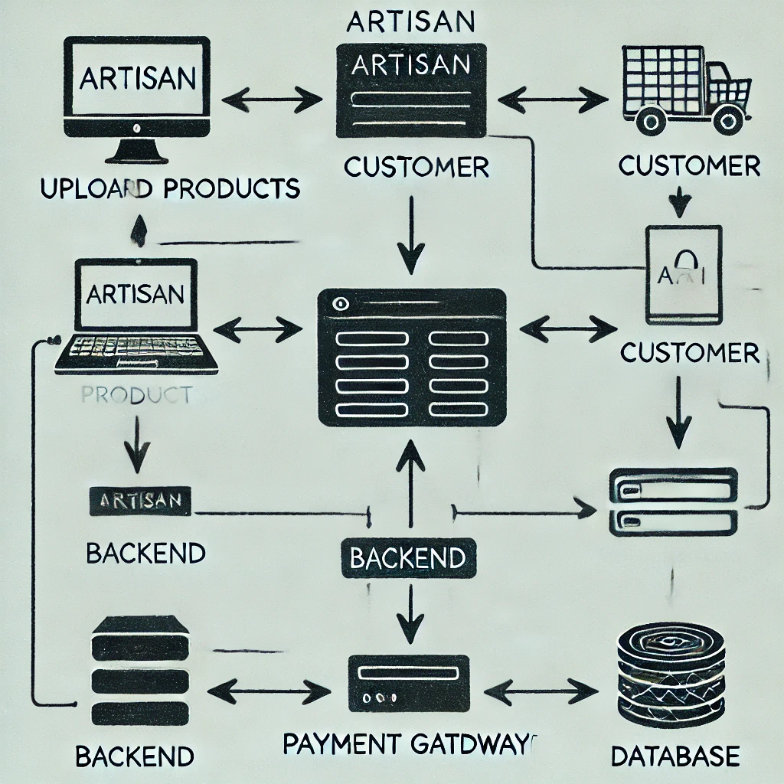

**7.Modules**

**Phase 1: Requirement Gathering: Analyze existing gaps and gather artisan-specific needs.**

**Phase 2: System Design: As the main objective is user friendly. We will focus much on that for front end**

**Phase 3: Development: Focus on user registration, secure transactions, Large database support.**

**Phase 4: Deployment: AWS cloud deployment for high availability.**

**Phase 5: Maintenance: Continuous updates based on artisan feedback.**

6. Dashboard & Analytics

**8.EXPECTED OUTCOMES**

**Empowerment of Rural Artisans**

**Outcome: The platform enables artisans to present their textiles and handicrafts to a global audience, extending their market access far beyond local boundaries.**

**Impact: Artisans gain enhanced visibility, allowing them to reach new customers and markets, thereby increasing their income and creating sustainable business opportunities.**

**Increased Sales and Revenue**

**Outcome: With a well-organized and secure platform, artisans can easily list products, conduct transactions, and interact with buyers seamlessly.**

**Impact: Boosted sales will directly enhance the artisans' revenue streams, contributing to their financial stability and overall economic growth.**

**Secure and Reliable Transaction System**

**Outcome: Integrating trusted payment gateways builds a safe environment for buyers and sellers, ensuring all transactions are secure.**

**Impact: This trust encourages repeat purchases and long-term relationships between artisans and customers, establishing a sustainable business ecosystem.**

**Simplified Digital Access for Artisans**

**Outcome: A user-friendly interface, coupled with multilingual support, makes the platform accessible even to those with minimal digital literacy.**

**Impact: This promotes inclusiveness by bridging the digital divide, empowering artisans who may otherwise struggle with complex technologies to engage in online commerce.**

**Global Market Expansion for Local Products**

**Outcome: The platform provides artisans with exposure to international buyers, facilitating the promotion of traditional textiles and crafts globally.**

**Impact: As demand grows for unique handmade products, the cultural and economic significance of these crafts will increase, benefiting both artisans and heritage preservation.**

**Strengthened Artisan Community and Networking**

**Outcome: The platform fosters communication and collaboration between artisans, allowing them to exchange ideas, co-create events, and learn from each other.**

**Impact: This collaborative environment strengthens community ties and enhances product quality through shared knowledge, driving innovation and professional growth.**

**9. TIMELINE OF THE PROJECT/ PROJECT EXECUTION PLAN**

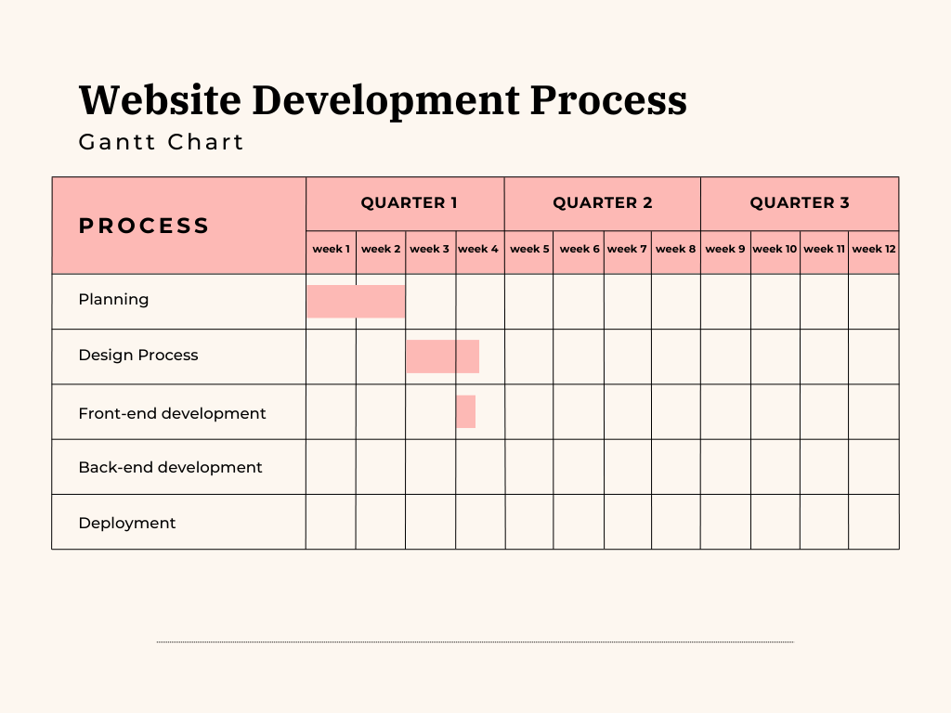

**10.CONCLUSION**

The development of an **e-commerce platform for rural artisans** offers a transformative pathway toward both **economic empowerment** and the **preservation of cultural heritage**. Rural artisans, often confined to local markets due to geographic isolation and limited digital exposure, will now have access to **structured and secure online marketplaces** that broaden their reach and visibility. Through this platform, they can transcend traditional trade limitations by directly connecting with global buyers, allowing their unique and handcrafted products to find new appreciation on an international stage​.

A **key objective** of the project is to create a **scalable solution** that not only boosts individual artisans' income but also fosters **sustainable economic development** in rural regions. By bypassing intermediaries and enabling artisans to retain a greater share of their profits, the platform encourages **economic independence**. This structure offers artisans the freedom to grow their businesses at their own pace, supported by **analytics tools** that provide insights into product performance, sales trends, and customer behaviour​.

Furthermore, the platform plays an essential role in **preserving and promoting cultural heritage**. Traditional crafts, textiles, and artisanal techniques, often passed down through generations, are at risk of disappearing due to urbanization and industrialization. By showcasing these products on a global platform, the initiative not only supports artisans financially but also **creates awareness about India’s rich artistic traditions**, fostering an environment of cultural appreciation​.

In the long term, the project aspires to **uplift rural communities socially and economically**. It encourages **community collaboration**, as artisans can organize events and share ideas through networking tools built into the platform. Additionally, **trust-building mechanisms** like phased payment systems (starting with COD and expanding to online payments) will further strengthen their business relationships, leading to repeat buyers and stable revenue streams​.

Ultimately, the platform aligns with broader **sustainable development goals (SDGs)** by promoting **decent work and economic growth (SDG 8)**, supporting **industry and innovation (SDG 9)**, reducing inequalities (SDG 10), and promoting **sustainable consumption and production patterns (SDG 12)**. It acts as a vital tool for **long-term rural empowerment**, encouraging artisans to grow their businesses independently while helping preserve the cultural essence of their crafts for future generations​.

**REFERENCES**

[**https://d1wqtxts1xzle7.cloudfront.net/105081538/E_Commerce_Website_for_Artisans**](https://d1wqtxts1xzle7.cloudfront.net/105081538/E_Commerce_Website_for_Artisans)

[**https://www.researchgate.net/profile/HubertEscaith/publication/356931583_Technolog Ecommerce_and_Handicrafts_When_traditional_creators_meet_21st_Century_businessmodels.pdf**](https://www.researchgate.net/profile/HubertEscaith/publication/356931583_Technolog%20Ecommerce_and_Handicrafts_When_traditional_creators_meet_21st_Century_businessmodels.pdf)

[**https://d1wqtxts1xzle7.cloudfront.net/105081538/E_Commerce_Website_for_Artisans-libre.pdf?1692280230=&response-content-disposition=inline%3B+filename%3DE_Commerce_Website_for_Artisans.pdf**](https://d1wqtxts1xzle7.cloudfront.net/105081538/E_Commerce_Website_for_Artisans-libre.pdf?1692280230=&response-content-disposition=inline%3B+filename%3DE_Commerce_Website_for_Artisans.pdf)

**file:///C:/Users/CHITRIKA/OneDrive/Documents/Downloads/PaperpublishedKIIT-Dec-2019.pdf**

[**https://voiceofresearch.org/Doc/Dec-2016/Dec-2016_7.pdf**](https://voiceofresearch.org/Doc/Dec-2016/Dec-2016_7.pdf)

[**https://www.researchgate.net/profile/Purvi-Derashri/publication/369742097_India's_Technological_Roadmap_for_MSMEs_Governance**](https://www.researchgate.net/profile/Purvi-Derashri/publication/369742097_India's_Technological_Roadmap_for_MSMEs_Governance)

**ResearchGate**: [E-commerce and Handicrafts](https://www.researchgate.net)

**GitHub**:

[Smart Communication Project](https://github.com/chitrika003/smartcommunication)

[KalaKriti](https://github.com/shopkalakriti/shopkalakriti.live)

[ArtisanHub](https://github.com/Nakib00/ArtisanHub-e-commerce) - Focus on regional crafts.

**Voice of Research**: [India's Technological Roadmap for MSMEs](https://voiceofresearch.org)